Global Calculation Setting up the GLM

This is where you need to control for variations in brain volume between participants, the best way to do this is to work out the total cranial volume.

This must be done before you start setting the GLM up as your covariate information is here!

To work out the total cranial volume you will need to utilise the ‘get_totals.m” file that I’ve attached to the email.

This will have this code on it:
function [t, files] = get_totals(files, thr, msk)
%get_totals - Returns image totals (sum over all voxels), in ml
% t = get_totals
% [t files] = get_totals(files, thr, msk)
% GUI file-selection is used if files not specified as argument (or empty).
%
% If thr is given, this will be treated as an absolute threshold
% (i.e. values below this will be zeroed, hence the total will better match
% the GM analysed in the voxelwise stats, with the same threshold masking).
%
% Similarly, if msk is specified this image will be used as an explicit
% mask (i.e. only non-zero mask voxels will be included).
% GUI file-selection is used if msk is given as empty string ('').
% [Currently, masking assumes that msk matches the voxel dimensions of each
% image, and that therefore, all images have the same dimensions.]

% check spm version:
if exist('spm_select','file') % should be true for spm5
spm5 = 1;
select = @(msg) spm_select(inf, 'image', msg);
elseif exist('spm_get','file') % should be true for spm2
spm5 = 0;
select = @(msg) spm_get(inf, 'img', msg);
else
error('Failed to locate spm_get or spm_select; please add SPM to Matlab path')
end

if ( ~exist('files', 'var') || isempty(files) )
files = select('choose images');
end
if ( ~exist('thr', 'var') || isempty(thr) )
thr = -inf; % default to include everything (except NaNs)
end
if ~exist('msk', 'var')
msk = 1; % default to include everything
end
if isempty(msk)
msk = select('Choose mask image');
end
if ischar(msk)
msk = spm_vol(msk);
end
if isstruct(msk)
msk = spm_read_vols(msk);
end
msk = msk ~= 0;

vols = spm_vol(files);
N = length(vols);

t = zeros(N,1);
for n = 1:N
vsz = abs(det(vols(n).mat));
img = spm_read_vols(vols(n));
img = img .* msk;
t(n) = sum(img(img > thr)) * vsz / 1000; % vsz in mm^3 (= 0.001 ml)
end

Open this file in MATLAB and then type ‘get_totals’ into the command window.

You then need to select the c1, c2 and c3 files for each participant and run this.

This will create a new variable in your workspace called ‘Ans’ this will take a very long time to be created so be patient.

What does this mean?
- C1 = grey matter, C2 = white matter, C3 = CSF, this will create a total volume score for the grey matter, white matter, and CSF for each participant.

To work out the total cranial volume of this, import this information into the excel sheet that you’re keeping for your participant IDs, age, gender (or whatever your controlling for/your covariates).
- You will then sum the scores for grey matter, white matter, and CSF for each participant (using the SUM function in Excel).
- Alternatively you can sum this when inputting into the SPM GUI for global calculation by stating info(:,4)+ info(:,5)+ info(:,6)

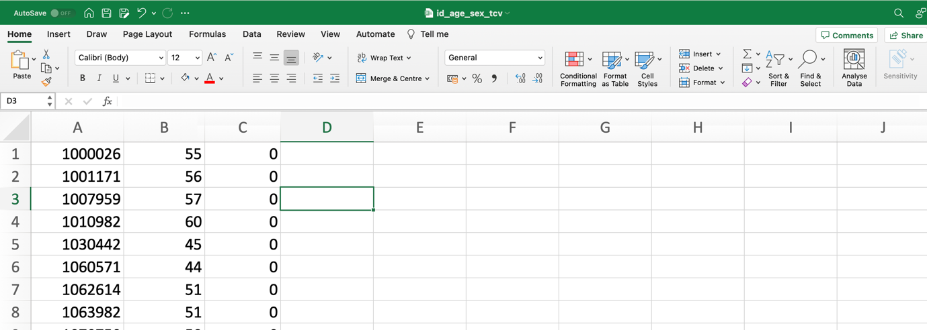
NOTE: make sure that you have no headings here, save it as the order of the columns. For example, this is mine before adding the TCV values in.

This will then have all the information required for your covariates (TCV, age, etc). Make sure you save this file within your working directory so that it will open in MATLAB.

You then should open this in MATLAB so when you’re entering your covariates in the GLM you simply need to state the location of the information in the file and if there is any coding.

To open in MATLAB:

info=readmatrix(‘filename.csv’);

For example, for mine if I was controlling for gender (which is coded) I’d state
info(:,3) and specifically state that values of 0 indicate a female subject, and 1 indicates male.

Whereas, if controlling for age, I’d simply need to state info(:,2).

